Blue fonts are all original texts in the experiment that need to be checked.
Please don’t turn off track changes as it is right now so I can see changes you make

- Initial test instructions

(1) A list of words will appear on the screen one at a time. Study the words as they appear.

(2) Then, after a brief blank period, you will see a series of numbers. Add those as they come, and when you see the words “TYPE THE SUM”, use the number keys to type your answer.

(3) Then, you will need to recall the words you study one at a time. You will see the first two letters of the words you JUST studied presented on the screen. Following each presentation, you will need to type in the rest of the words you remembered.

There will be 10 lists of words, each followed by a test.

Do not worry if you were unsure about the words during the test. That is normal, but make your best guess.

Please start the practice list now by pressing the enter key.

  - Initial test prompts
    - Now you will see the study list, remember the words as they appear
    - Summing up the digits as they appear
    - Please enter the sum using your number keyboard: ____
      - CORRECT
      - INCORRECT
    - Now recall the words you JUST studied.
  - Placeholder and prompt for testing, looks like that in screenshot
    - Placeholder: Type the word starting with ‘xx’ or ‘none’
    - Prompt: Type the whole word you just studied, starting with ‘xx____:”. Type ‘none’ if you don’t recall
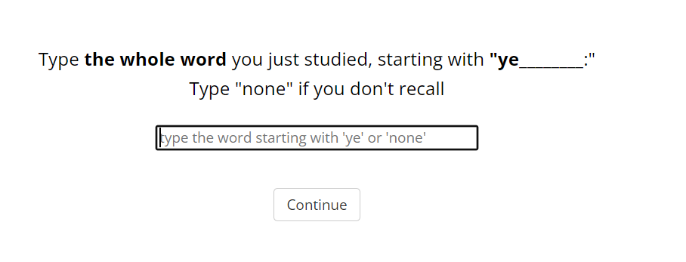
  - Initial test feedback (for one blank)

CW for Correct Word;
ICW for INcorrect Word;

Response | Feedback
CW | CORRECT!
ICW | INCORRECT
none | No feedback

  - Initial test feedback second line:
    - Please enter the FULL words starting with the first two letter cues!
    - It took too long to answer the word. Please pay attention and respond faster!

- Final test instructions

You have now completed the first part of the study. The next part will test your memory for ALL the words you have seen in this study.

You will see two letter cues, just as before, but now there will be two spaces to type words beginning with those two letters:

For [some] cues you will have seen [only one word] beginning with those letters; and for [some] cues you will have seen [two words] beginning with those letters.
1. The first blank:
(1) If you can [recall one word], type it in the first space, and then type it in the first blank.
(2) If you don't remember, type "none".

2. The second blank:
You have now completed the first part of the study. The next part will test your memory for ALL the words you have seen in this study.

You will see two letter cues, just as before, but now there will be two spaces to type words beginning with those two letters:

For some cues you will have seen only one word beginning with those letters; and for some cues you will have seen two words beginning with those letters.

The first blank:
(1) If you can recall one word, type it in the first space, and then type it in the first blank.
(2) If you don't remember, type "none".

The second blank:
(1) You can then try to recall a second word from the study with those letters.
(2) You can also type "none" key when you have typed one word and can remember no others, or if there is no word you remembered at all.

You will then be shown the feedback (correct/incorrect) with word(s) and the list(s) in which they were studied. And then will be given the next two letter cue.

Try to respond as fast and as accurate as possible.

If you have read and understood these new instructions, press the 'p' key to go to the testing.

- Final test prompt

Type the whole word you studied in ALL previous lists, starting with ‘xx____’
If you only remember one word, please enter it in the first blank space.

The first word if you remember:
______type the word starting with ‘pr’ or ‘none’____
The second word if you remember:
______type the word starting with ‘pr’ or ‘none’____

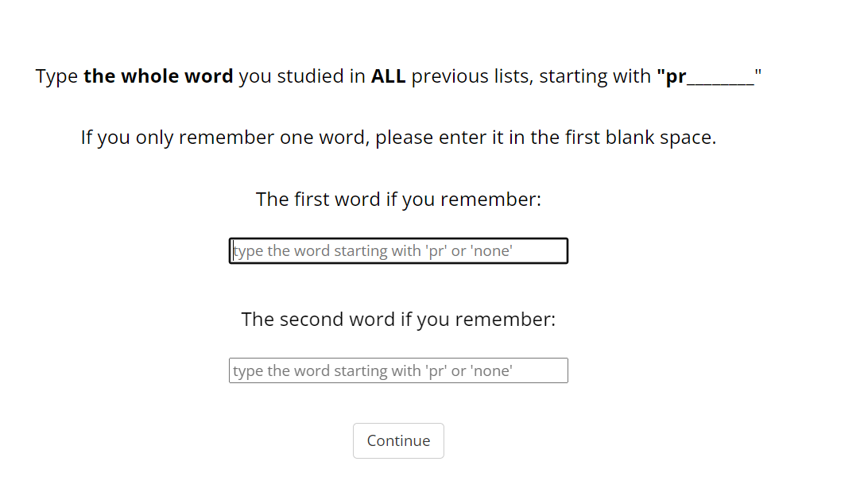
- Final test feedback-unique condition

CW for Correct Word;
ICW for INcorrect Word;
N for none

 | Possible response (8 possibility) | Feedback
1 | CW  ICW | Word 1: CORRECT! The word was seen in list xx.  Word 2: INCORRECT! There is no other word.
2 | CW  N | Word 1: CORRECT! The word was seen in list xx.  Word 2: CORRECT! There is no other word.
3 | N  CW | Word 1: CORRECT! There is no other word.  Word 2: CORRECT! The word was seen in list xx.
4 | ICW  CW | Word 1: INCORRECT! There is no other word.  Word 2: CORRECT! The word was seen in list xx.
5 | ICW  N | Word 1: INCORRECT! There was a word seen in list xx.  Word 2: CORRECT! There is no other word.
6 | ICW  ICW | Word 1: INCORRECT! There was a word seen in list xx.  Word 2: INCORRECT! There is no other word.
7 | N  ICW | Word 1: INCORRECT! There was a word seen list xx.  Word 2: INCORRECT! There is no other word.
8 | N  N | Word 1: There was a word seen in list xx.  Word 2: There is no other word.

- Final test feedback repeats conditions
CW1 for Correct Word that is correctly respond from first of the paired lists
CW2 for Correct Word that is correctly respond from second of the paired lists
ICW for Incorrect Word;
N for none

List xx1 is list where CW1 came from.
List xx2 is list where CW2 came from.

 | Possible response (8 possibility) | Feedback
 | CW1  ICW | Word 1: CORRECT! The word was seen in list xx1.  Word 2: INCORRECT! There was another word seen in list xx2.
 | CW2  ICW | Word 1: CORRECT! The word was seen in list xx2.  Word 2: INCORRECT! There was another word seen in list xx1.
 | CW1  N | Word 1: CORRECT! The word was seen in list xx1.  Word 2: There was another word seen in list xx2.
 | CW2  N | Word 1: CORRECT! The word was seen in list xx2.  Word 2: There was another word seen in list xx1.
 | N  CW1 | Word 1: There was another word seen in list xx2.  Word 2: CORRECT! The word was seen in list xx1.
 | N  CW2 | Word 1: There was another word seen in list xx1.  Word 2: CORRECT! The word was seen in list xx2.
 | ICW  CW1 | Word 1: INCORRECT! There was another word seen in list xx2.  Word 2: CORRECT! The word was seen in list xx1.
 | ICW  CW2 | Word 1: INCORRECT! There was another word seen in list xx1.  Word 2: CORRECT! The word was seen in list xx2.
 | ICW  N | Word 1: INCORRECT! There was a word seen in list xx1.  Word 2: There was another word seen in list xx2.
 | ICW  ICW | Word 1: INCORRECT! There was a word seen in list xx1.  Word 2: INCORRECT! There was another word seen in list xx2.
 | N  ICW | Word 1: There was a word seen in list xx1.  Word 2: INCORRECT! There was another word seen in list xx2.
 | N  N | Word 1: There was a word seen in list xx1.  Word 2: There was another word seen in list xx2
 | CW1  CW2 | Word 1: CORRECT! The word was seen in list xx1.  Word 2: CORRECT! The word was seen in list xx2.
 | CW2  CW1 | Word 1: CORRECT! The word was seen in list xx2.  Word 2: CORRECT! The word was seen in list xx1.

